**Runbook for Ansible Tower Creation and An Example Playbook**

1. Spin up an EC2 instance with AMI named “**Red Hat Enterprise Linux 8 (HVM)**” - - - **use instance with a minimum 8gb**

**Open the SG to https 0.0.0.0/0 or just your ip**

2. Once it is up and running, login to the EC2 instance

3. Use below commands to install Ansible

a. sudo dnf install https://dl.fedoraproject.org/pub/epel/epel-release-latest-8.noarch.rpm -y

b. sudo dnf install ansible -y

4. Below commands are used download Ansible Tower file and Unzip

a. sudo yum install wget -y

b. wget https://releases.ansible.com/ansible-tower/setup/ansible-tower-setup-latest.tar.gz

c. tar xvzf ansible-tower-setup-latest.tar.gz

5. Please do a ‘ls’ to view which version of Ansible Tower got downloaded and update the version number in the below command

a. cd ansible-tower-setup-<tower_version>

6. Once you get into the Ansible that should look like below image

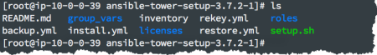

7. We need to edit inventory file. Please follow below commands and instructions in setting up the password for the Ansible tower

a. vi inventory

b.

c. We need to add password in the above specified places

d. Esc .qw! to save the file

8. Our Ansible Tower pre-setup is completed. Lets install Ansible Tower from below command.

1. **sudo ./setup.sh**

b. Please wait Approx 5 to 10 Minutes and let the Ansible Tower installation gets completed.

9. Create an account in Redhat portal

a. https://www.redhat.com/wapps/ugc/register.html

10. Once you create the account at Redhat portal. Please login to the below URL for subscriptions

a. https://access.redhat.com/management/subscriptions

Your subscriptions should contain “60 Day Evaluation of Red Hat Ansible Automation, Self-Supported (100 Managed Nodes)”

b. Reference Image:

c.

11. Now we need to launch our Ansible Tower with Public IP of EC2 we launched on a Web Browser

12.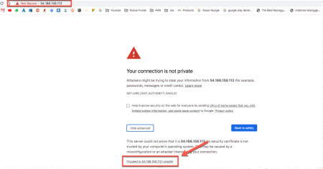

13. 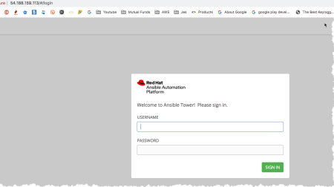14. Username : admin

15. Password : You entered in inventory file 16. Then you will get the below

17.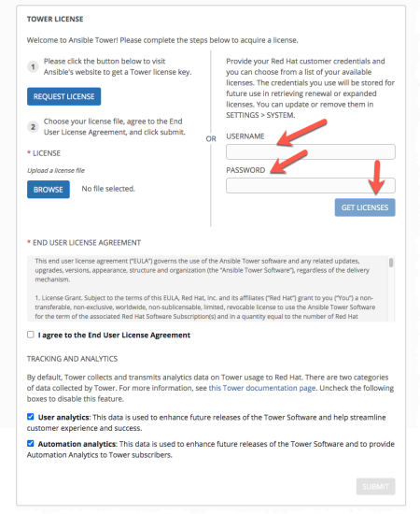

18. 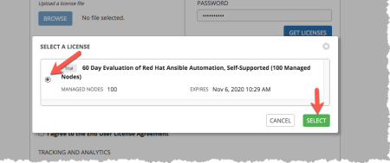19. 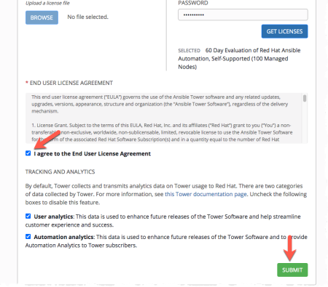20. If the Ansible Tower installation is successful. Reference image is below

21. 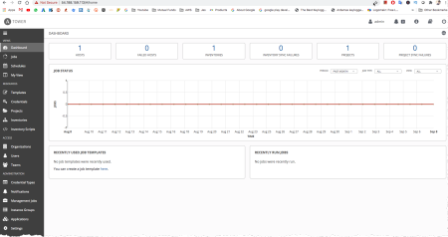

22. Once we setup our Ansible Tower. Follow below instructions to create an example. 23.

24. Create a private repository in github and name it JJTechTower. Give it a Readme file name

a. CD to Desktop and create a folder name GithubSrc, clone the repository with git clone command to a folder on your local

b. Clone another repository which contains the code we will use $ git clone https://github.com/tantuch19/JJTech-Bliss-Ansible-Tower.git

c. Use the below command to copy the contents of the file to your newly created repository.

$ cp * /Users/susannekangnoh/Desktop/GitHubProjects/testtower

d. run git add ., git commit, git push ( use git status in between to see the changes that are being made on each level)

i. git add . ( make your untracked files to become tracked by git)

ii. git commit ( committing the files so they can be pushed to a repository) iii. git push (pushes everything to a repo)

e.

25. Set up Authentication. Ansible needs to authenticate into your github and it also needs to authenticate to your AWS account.

a. Go to credentials and click on the plus sign.

b. For Github give it the name Github-Repo, Organization=Default, Credential Type = Source Control (Enter the username and password to your github account) Click on Save and you should see the credentials added at the bottom.

c. For AWS: give it a name AWS-Authentication, Organization- Default), Credential type = Amazon Web services, Add Access key and Secret Access key. Save

26. 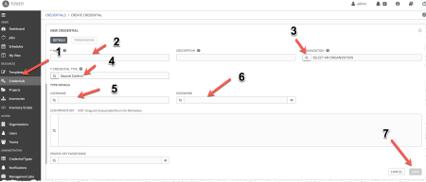

27. Set up a project: Go to projects and click on the plus sign to create a new project. a. Project Name - ec2-provisioning automation.

b. SCM= Git.

c. SCM url = your github repository url.

d. SCM Credential = Select the credential you created fir github

e. SCM update options = Select the first 3 and save

28. Create template: Go to templates and click on the plus sign select the job template and provide a template name.

a. Inventory = Select the Demo or default inventory

b. Project = Select the project that you created.

c. Playbook = select the ec2.yml playbook. ( if you did not set up the repo properly you will not see the right playbook)

d. Credentials = Credential type should be AWS and the authentication credentials you created

29.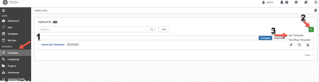

30. 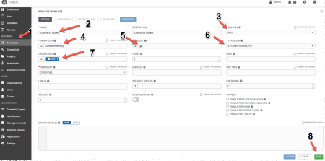

31. Once you save it we need to create survey. Click on Add survey. Enter each of the details below in the survey and click on Add

| Prompt | Descriptio  Answer Variable Name Answer Type  n |
| --- | --- |
| Please choose your team | team Multiplechoice  single select  BlissBatch  DeveloperTeam,  Testingteam |
| Please choose  your security  group | security_group Multiple choice:  BankEnd  Restricted  Core |
| Please choose  an AMI | ami_type Multi choice:  Rhel  Ubuntu  Windows  AmazonLinux |
| Please choose  your Subnet | vpc_subnet_id AZa  AZb  Azc |

Please choose your instance role

instance_role admin s3

| Please enter the volume size | root_volume_size Text |
| --- | --- |
| Enter the EC2  instance name | instance_name Text |
| Please enter  your Name or work email | created_by Text |
| Please choose  an instance type | instance_type t2.micro  t2.medium  t2.large  t2.small |
| Please provide the required  owner tag  Please provide a required app name tag | Owner Text  App_Name Text |
| Please provide a required cost center tag | Cost_Center Text |
| Please provide a required  business unit tag | Business_Unit Text |
|  |  |
|  |  |

32. Create parameters ( in US-East-1) using the below keys and enter the value as it applies in your environment.

a. /JJTech/BlissBatch/AZa ( value is subnet for AZa)

b. /JJTech/BlissBatch/AZb ( value is subnet for AZa)

c. /JJTech/BlissBatch/Azc ( value is subnet for AZa)

d. /JJTech/BlissBatch/AmazonLinux (value is amazon linux AMiID)

e. /JJTech/BlissBatch/BackEnd (security groupID from the same VPC that has your subnets)

f. /JJTech/BlissBatch/Core (security groupID from the same VPC that has your subnets)

g. /JJTech/BlissBatch/Restricted (security groupID from the same VPC that has your subnets)

h. /JJTech/BlissBatch/Rhel (AMI)

i. /JJTech/BlissBatch/Ubuntu (AMI)

j. /JJTech/BlissBatch/Windows (AMI)

k. /JJTech/BlissBatch/admin (Enter any role name in your account as a value)

l. /JJTech/BlissBatch/keyname (enter any keypair)

33. 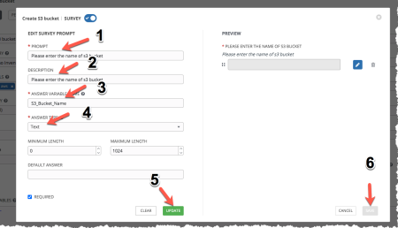

34. Once you create the survey please launch the template and enter name of the s3 bucket to create

For ec2 demo please download below playbook

https://jjtech-trainings.s3-us-west-2.amazonaws.com/ansible-tower/create-ec2.yml